Science & Technology Department

Interamerican University of Puerto Rico

Aguadilla Campus

XYZ Company

Manual 2026

Ektor M. González Ramos

A00617167

COTN2122.NETWORK ADMINISTRATION II

May 13, 2026

Prof. Samuel Rodriguez Roman

Table of Contents

- Active Directory Introduction
1.1. Overview
1.2. Users
1.3. Groups
1.4. Group Policies
- Getting Started
  - Users
    - Creating Users
    - Adding Users Information
  - Groups
    - Creating Groups
    - Changing Groups Scope
  - DNS, WINS, and DHCP
    - DNS
      - Creating DNS zones
      - Creating DNS record
    - WINS
      - Configuring DNS
    - DHCP
      - Configuring DHCP scope
      - Configuring reservations
2.4. Computers
2.5. Group Policy (Linking, General, Security, File System, Software Deployment)
2.6. Validating the Implementation
- References

1. Active Directory Introduction

1.1. Overview

Active Directory is a distributed database responsible for storing and managing network resource information, along with application-specific data generated by directory-enabled applications. According to Tomsho (2017) a domain is a logical container that groups all network resources, where each resource is represented as an object. To maximize efficiency, Active Directory replicates only modified properties rather than entire accounts and adapts to the available network link speed. The Active Directory schema defines the types of objects that can be stored in the directory, along with the information associated with each, where a user account is one example of an object class defined by its own unique schema elements (Tomsho 2017).​​​​​​​​​​​​​​​​

Forest – A collection of one or more domain trees that share a common schema and global catalog.

Tree - A group of domains arranged in a contiguous namespace hierarchy, connected by two-way trust relationships.

Domain - A logical partition within a forest that serves as the primary container for grouping directory objects.

Organizational Unit (OU) - A container within a domain used to group related objects for easier administration and policy application.

Site - A TCP/IP-based container linked to IP subnets that groups objects by physical location to optimize communication paths.​​​​​​​​​​​​​​​​

Domain controllers are servers that run the AD DS role, hosting the directory database and SYSVOL while handling authentication through Kerberos, with best practices recommending at least two per domain alongside security measures like RODC and BitLocker.​​​​​​​​​​​​​​​​ The global catalog is a forest-wide repository that holds a full replica of objects within its own domain and a partial replica from all other domains, enabling authentication, resource lookup, and efficient replication, with the first DC in a forest automatically taking on this role.​​​​​​​​​​​​​​​​ Active Directory relies on DNS for name resolution and namespace management, supporting both contiguous namespaces, where child objects inherit the parent’s name, and disjointed namespaces, where the child’s name bears no resemblance to its parent.​​​​​​​​​​​​​​​​ In this project, XYZ Company implements a single Active Directory forest containing one domain (xyz.local) with a single Domain Controller named XYZ-DC1. This server also hosts the DNS, WINS, and DHCP roles required by the project specification, consolidating directory services and network services on a single machine. The following subsections describe how user accounts, security groups, and Group Policy Objects are organized within this directory structure.

1.2. Users

A user account in Active Directory is an object that represents a person who needs to authenticate against the domain to access network resources. AD provides two default accounts, Administrator and Guest, and allows authorized roles such as Domain Admins and Account Operators to create and manage security principals through the Active Directory Users and Computers console, with permissions varying by group membership.​​​​​​​​​​​​​​​​ User accounts can exist either as local accounts on a stand-alone server without Active Directory, or as domain accounts managed centrally through AD once it is installed.​​​​​​​​​​​​​​​​ When creating a user account in Active Directory, administrators can configure a wide range of attributes spanning personal information, contact details, account settings, profile, organizational data, and remote access options, among others.​​​​​​​​​​​​​​​ When creating an Active Directory account, administrators can apply several security restrictions, including:

Logon hours — limits the times during which a user is permitted to log on.

Logon workstations — restricts which computers the user can log on to.

Account expiration — sets a date on which the account automatically becomes inactive.

Account lockout — disables the account after a defined number of failed logon attempts.

Referencing Tomsho (2017), AD DS objects can be managed through graphical tools such as the Active Directory Administrative Center and its snap-ins, or through command-line tools including the Active Directory PowerShell module and Directory Service commands.​​​​​​​​​​​​​​​​ In this project, XYZ Company applies a naming convention of first initial followed by full last name (for example, John Smith becomes JSmith), with the middle initial added when two users would generate the same logon name (John Harold Smith becomes JHSmith). Nine user accounts are created and distributed across the Marketing, Sales, Finance, Information Technology, Help Desk, and Network Support OUs. Moira Cowan, VP of Marketing, is configured with detailed attribute information. This includes title, department, office, telephone, email, and full address. That demonstrate how AD can serve as the central source of user information for other directory-enabled applications such as Exchange and SharePoint. All accounts are restricted to logging on Monday through Friday from 7:00 AM to 8:00 PM, are blocked from weekend access, and are prevented from changing their own passwords.

1.3. Groups

Active Directory defines two primary types of security principals, user accounts and computer accounts, which represent physical entities such as people or computers, and organizes them alongside other groups through security groups into manageable units (Microsoft, 2025).​​​​​​​​​​​​​​​ Security groups simplify network administration by consolidating user accounts, computer accounts, and other groups into manageable units, making it more efficient to assign permissions to shared resources compared to managing individual users. According to Tomsho (2017), AD supports two group types: distribution groups, which are limited to email applications and cannot be assigned permissions, and security groups, which hold a security identifier (SID) that allows them to be granted permissions while also supporting email functionality, with both types being interconvertible. Active Directory defines four group scopes:​​​​​​​​​​​​​​​​

Local - accepts users, computers, global, domain-local, universal groups, and local users from the same domain, as well as users, computers, and global and universal groups from domains in the same forest or trusted external domains; permissions can only be assigned to resources on the local computer.

Domain-Local - accepts users, computers, global, domain-local, and universal groups from the same domain or any domain in the same forest, and users, computers, and global groups from trusted external domains; permissions can be assigned to any resource within the domain.

Universal - accepts users, computers, global, and universal groups from the same domain or any domain in the same forest, but not from trusted external domains; permissions can be assigned to any resource across the entire forest.

Global - accepts only users, computers, and global groups from the same domain, with no membership from external or forest domains; permissions can be assigned anywhere in the domain or in a trusted domain.​​​​​​​​​​​​​​​​

According to Microsoft (2025), The AGDLP strategy is a Microsoft best practice for managing permissions by nesting user accounts into global groups, which are then added to domain-local groups, where permissions to resources are ultimately assigned.​​​​​​​​​​​​​​​​ Windows Server includes several default groups with predefined administrative privileges that should be managed carefully, among which Print Operators stands out as particularly significant, as its members can manage printers connected to domain controllers and log on to them interactively.​​​​​​​​​​​​​​​​ Special identities are system-managed groups whose membership is controlled by the operating system and used to grant access to resources based on the type of authentication or connection rather than individual user accounts, with key examples including Anonymous Logon, Authenticated Users, Everyone, Interactive, Network, and Creator Owner​​​​(Tomsho, 2017). In this project, XYZ Company creates twelve security groups distributed across the six departments, organized as paired Users and Resources groups per department. Marketing Users is assigned Universal scope to anticipate possible future expansion of the company into additional AD domains, while the remaining Users groups (Sales, Finance, IT, Help Desk, and Network Support) use Global scope to optimize replication to the Global Catalog. The AGDLP strategy is applied here through nested membership: each Users group is added as a member of its corresponding Resources group, and permissions on shared resources such as the C:\Reports folder are assigned to the Domain Local Resources group rather than to individual users. Finally, the Help Desk Users, IT Users, and Network Support Users groups are added as members of the built-in Print Operators group to allow the technical support staff to manage printers connected to the DC and log on locally to the server, and the Authenticated Users special identity is used as the Security Filtering scope for the Marketing Policy GPO described in subsection 1.4.

1.4. Group Policies
Group Policy in Windows Server 2016 allows administrators to standardize the working environment across clients and servers by enforcing configurations through Active Directory, where settings are stored in GPOs and can be applied at the site, domain, OU, or local computer level, but not to non-OU folder containers.​​​​​​​​​​​​​​​​ A Group Policy Object (GPO) is a collection of Group Policy settings that define specific configuration changes and can be applied to users, computers, or both within an Active Directory environment.​​​​​​​​​​​​​​​​ Group Policy settings are divided into computer configuration are applied at system startup, and user configuration are applied at sign-in, both capable of running synchronously, where the process waits for policy application to complete, or asynchronously, where the system continues without waiting and refreshes policy periodically in the background (Microsoft, 2025).​​​​​​​​​​​​​​​​ A domain GPO stores its content across two locations: the Group Policy Container, held in AD DS and responsible for version information, and the Group Policy Template, stored in the shared SYSVOL folder and containing the actual policy settings.​​​​​​​​​​​​​​​​ Group Policy is processed in the order of Local, Site, Domain, and OU (LSDOU), where later policies take precedence over earlier ones in the event of a conflict.​​​​​​​​​​​​​​​​ Group Policy refreshes automatically at regular intervals, with security settings updating at least every 16 hours, and can be forced manually at any time using the gpupdate /force command or the Invoke-Gpupdate PowerShell cmdlet.​​​​​​​​​​​​​​​​ According to Tomsho (2017), Security policies are a subset of Group Policy, applied at the site, domain, OU, or local computer level, and encompass settings such as Account Policies, Audit Policy, User Rights, Security Options, and IP Security Policies.​​​​​​​​​​​​​​​​ The Group Policy Management Console (GPMC) is the primary tool for managing all aspects of Group Policy across multiple forests, offering capabilities such as importing, exporting, backing up, and restoring GPOs, as well as modeling and results features for planning and troubleshooting deployments (Microsoft, 2025). ​​​​​​​​​​​​​​​​ In this project, a single GPO named Marketing Policy is created and linked exclusively to the Marketing OU, with the Authenticated Users special identity defined in its Security Filtering so that the policy applies only to users within that organizational unit. The GPO consolidates several categories of settings: a standardized desktop environment (wallpaper, restricted Start Menu and Control Panel access), password and account lockout policies, an interactive logon banner, NTFS share permissions on the Reports folder, and automatic deployment of the 7-Zip MSI package. The detailed configuration of each individual setting is described in subsection 2.5 of this manual.

2. Getting Started
This section explains step by step how to recreate the demonstration that was presented to the Board of Trustees. Every step starts from the Windows Server 2016 desktop of the Domain Controller (XYZ-DC1) logged in as the local Administrator. All actions are performed from Server Manager and its Tools menu unless stated otherwise.

2.1. Users

2.1.1. Creating Users
User accounts are created from the Active Directory Users and Computers (ADUC) console. The procedure below is repeated once per user; the only fields that change are First name, Last name, and User logon name (according to the naming convention).
- From the desktop, open Server Manager.
- In the Server Manager menu bar, click Tools and select Active Directory Users and Computers.
- In the left pane, expand xyz.local and right-click on the Organizational Unit where the user belongs (for example, Marketing).
- Choose New > User.
- Fill in the First name and the Last name. The Full name and the User logon name fields update automatically; correct the logon name if needed to follow the naming convention (first initial + last name, plus the middle initial in case of conflict).
- Click Next, type the password Password01 in both fields, uncheck "User must change password at next logon", check "User cannot change password" and click Next.
- Click Finish to create the user.

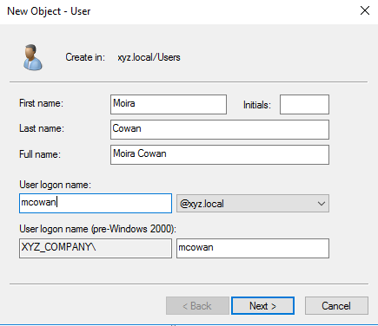
Figure: New User wizard. The Create in: line shows the destination OU.
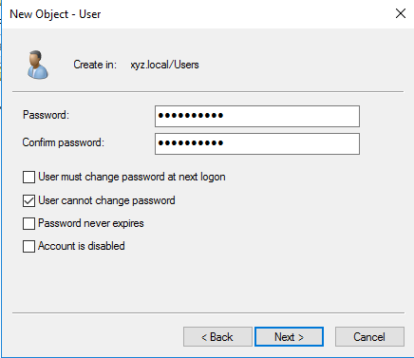
Figure: Setting the initial password and the User cannot change password flag.

2.1.2. Adding Users Information
XYZ Company asked that at least one user account contain detailed personal information so that other Microsoft products that read from Active Directory (Exchange, SharePoint, Skype for Business, etc.) can pull that information directly from the directory. Moira Cowan, VP of Marketing, was selected as the example. Her detailed attributes are added through the user properties dialog after the account is created.
- In ADUC, navigate to the Marketing OU and double-click on Moira Cowan to open her properties.
- Click the General tab and enter the description, office, telephone number, e-mail, and web page.
- Click the Address tab and enter the street, city, state, ZIP/postal code, and country.
- Click the Organization tab and enter the job title, department, and company.
- Click the Account tab and click Logon Hours to define the allowed working hours; then click Apply and OK.
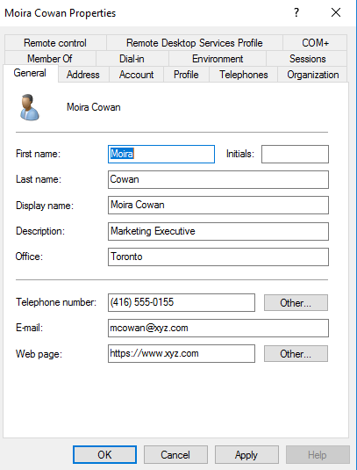
Figure: General tab — display name, description, office, telephone, e-mail, and web page.

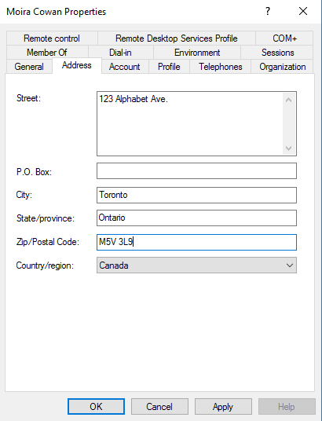
Figure: Address tab — street, city, state, ZIP, and country.
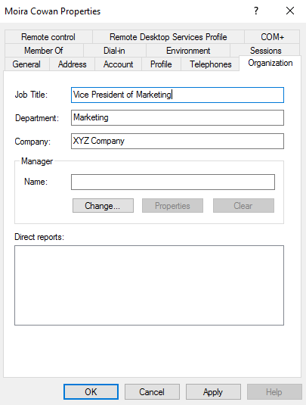
Figure: Organization tab — job title, department, and company.

Logon Hours are set graphically in a 24x7 grid where blue cells mean Logon Permitted and white cells mean Logon Denied. To match the policy of XYZ Company, the entire grid is first set to Logon Denied and then the cells corresponding to Monday through Friday from 7:00 AM to 8:00 PM are switched to Logon Permitted. The same procedure is applied to every user (a sample for Frank Adili is shown below).

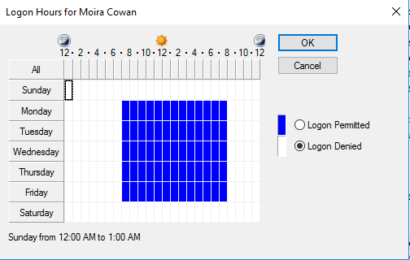
Figure: Logon Hours dialog — Monday through Friday 7:00 AM to 8:00 PM.
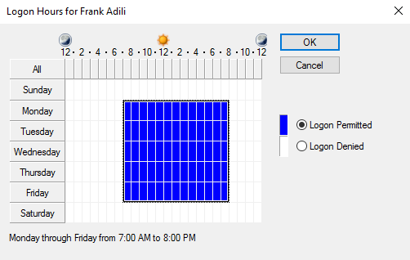
Figure: Same Logon Hours pattern applied to Frank Adili.
Once all nine users are created and their attributes (and Logon Hours) are set, the Users default container shows the complete list of accounts and security groups for the domain.
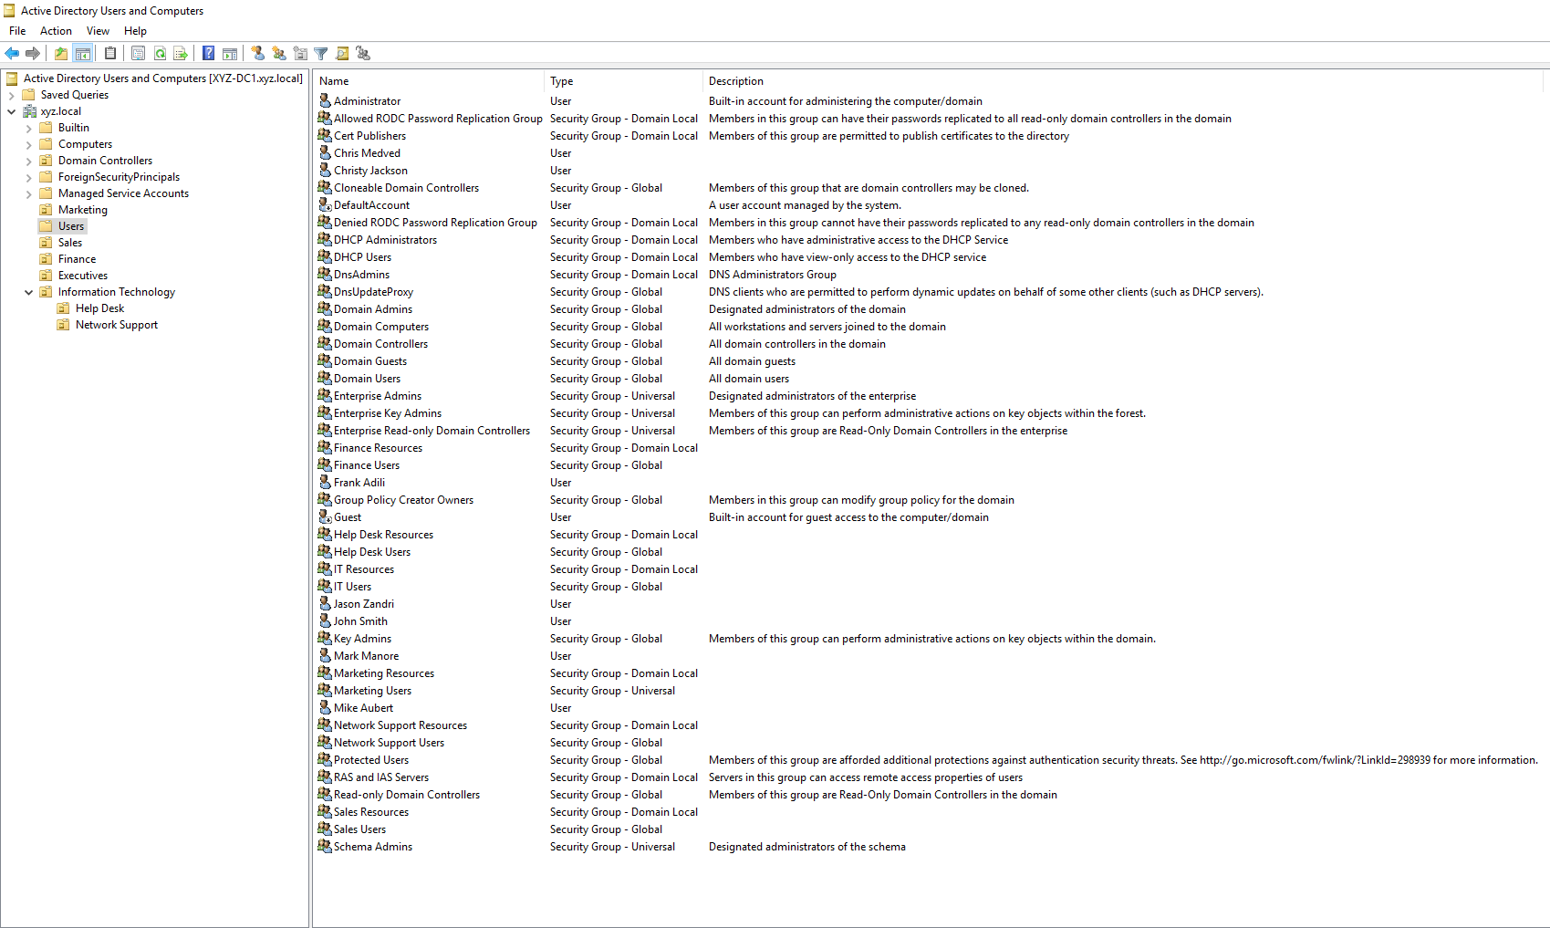
Figure: Active Directory Users and Computers — all nine users and the security groups.

2.2. Groups

2.2.1. Creating Groups
Groups are created in the same console (ADUC) as user accounts. For neatness, each Users and Resources group is created inside its corresponding department OU; this keeps the directory structure aligned with the organizational chart.

- From the desktop, open Server Manager > Tools > Active Directory Users and Computers.
- In the left pane, right-click the OU that should contain the group and select New > Group.
- Type the group name (for example, Sales Users).
- Choose the correct Group scope (Universal for Marketing Users, Global for the other Users groups, Domain Local for every Resources group).
- Leave Group type as Security and click OK.
The full table of groups created for the demonstration is reproduced below. After every group is created, its members are added through the Members tab of the group properties dialog.
Group | Scope | Members
Marketing Users | Universal | Moira Cowan, John Harold Smith
Marketing Resources | Domain Local | Marketing Users
Sales Users | Global | Frank Adili, Christy Jackson
Sales Resources | Domain Local | Sales Users
Finance Users | Global | Chris Medved
Finance Resources | Domain Local | Finance Users
IT Users | Global | Mark Manore
IT Resources | Domain Local | IT Users
Help Desk Users | Global | John Smith
Help Desk Resources | Domain Local | Help Desk Users
Network Support Users | Global | Mike Aubert, Jason Zandri
Network Support Resources | Domain Local | Network Support Users
Print Operators (Built-in) | Domain Local | Help Desk Users, IT Users, Network Support Users

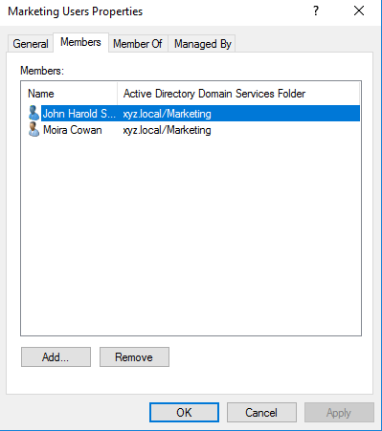
Figure: Marketing Users — Members tab showing Moira Cowan and John Harold Smith.

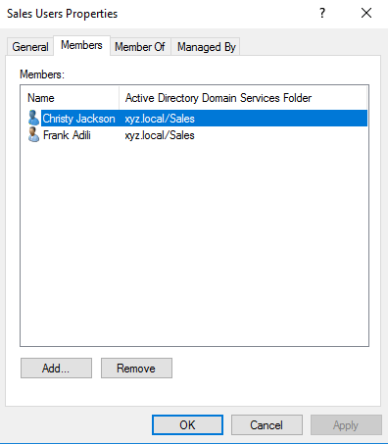
Figure: Sales Users — Frank Adili and Christy Jackson.
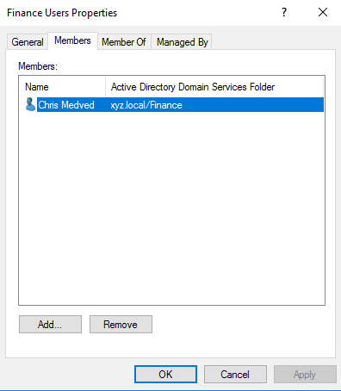
Figure: Finance Users — Chris Medved.

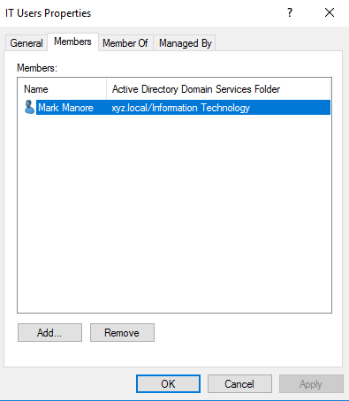
Figure: IT Users — Mark Manore.
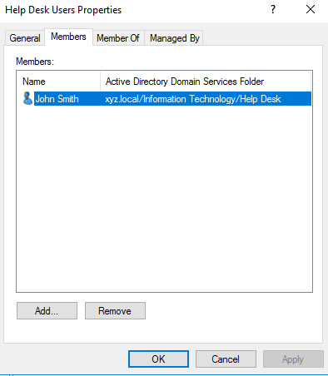
Figure: Help Desk Users — John Smith.
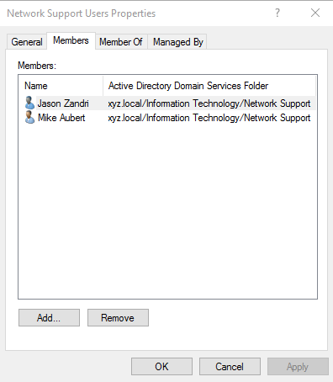
Figure: Network Support Users — Mike Aubert and Jason Zandri.
After the Users groups are populated, each one is added as a member of the corresponding Resources group. This is the A-G-DL-P pattern: user Accounts go into Global groups; Global groups go into Domain Local groups; Permissions on resources are then granted to the Domain Local groups.
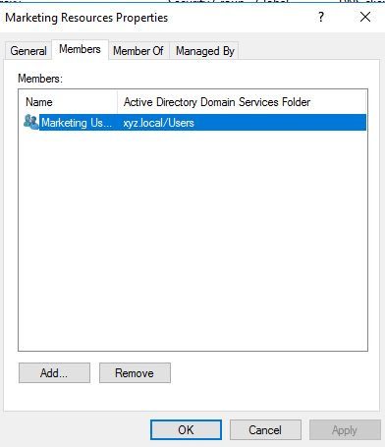
Figure: Marketing Resources contains the Marketing Users group.

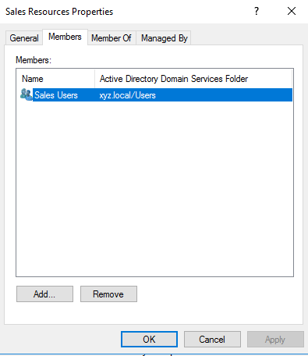
Figure: Sales Resources contains Sales Users.
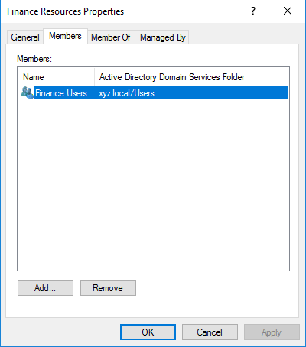
Figure: Finance Resources contains Finance Users.

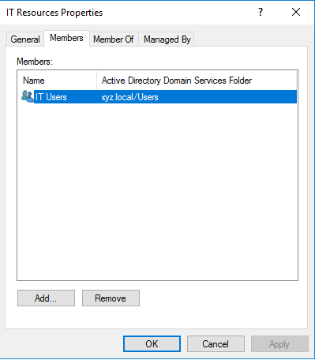
Figure: IT Resources contains IT Users.
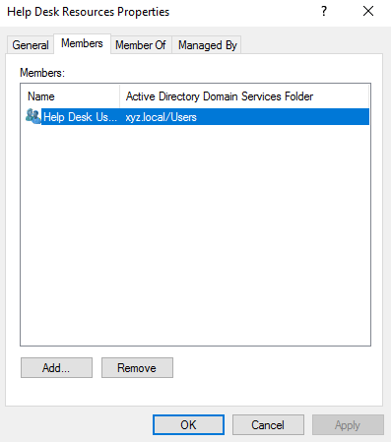
Figure: Help Desk Resources contains Help Desk Users.
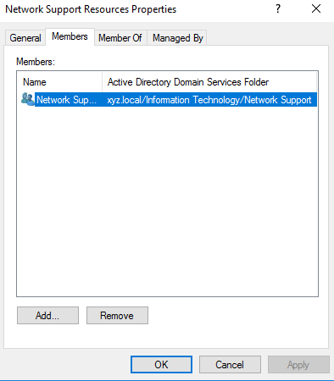
Figure: Network Support Resources contains Network Support Users.
Finally, the Help Desk Users, IT Users, and Network Support Users groups are added as members of the built-in Print Operators group. Print Operators is one of the few groups whose members are allowed to log on locally to a Domain Controller; it also lets the technical-support staff manage the printers attached to the server.
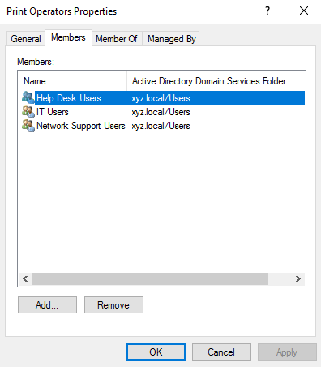
Figure: Print Operators — members from the three technical-support Users groups.

2.2.2. Changing Groups Scope
Group scope is selected when the group is created, but it can also be modified afterwards from the General tab of the group properties dialog. To change the scope of an existing group:
- Open Active Directory Users and Computers.
- Navigate to the OU that contains the group and double-click on the group name.
- On the General tab, locate the Group scope section and select the desired scope (Universal, Global, or Domain Local).
- Click Apply, then OK.
Note: Active Directory restricts which scope changes are allowed depending on the current scope and the membership of the group. A Domain Local group (for instance) can’t be converted directly to Global; it must first be promoted to Universal. The Marketing Users group in this project was changed to Universal to anticipate future multi-domain expansion.

2.3. DNS, WINS, and DHCP
XYZ Company policy is that every client receives an IP address from the 10.0.0.0/8 network and is able to contact every other computer by IP address and by computer name. The first 50 usable addresses are reserved for servers, printers, and connection equipment. To meet that policy, the Domain Controller hosts three services: DNS for name resolution, WINS for legacy NetBIOS resolution, and DHCP for automatic address assignment.

2.3.1. DNS
Domain Name System (DNS) is the Internet-standard name-resolution service. Active Directory depends on DNS for clients to locate Domain Controllers. The DNS role is installed automatically when Active Directory Domain Services is added; the forward zone xyz.local is created at the same time.

2.3.1.1. Creating DNS zones
Two zones are needed: a forward zone (name to IP) and a reverse zone (IP to name). The forward zone xyz.local is created automatically. The reverse zone for the 10.0.0.0/8 network is created manually:
- From the desktop, open Server Manager > Tools > DNS.
- In the left pane, expand XYZ-DC1 and right-click on Reverse Lookup Zones.
- Select New Zone... and click Next.
- Choose Primary zone and check Store the zone in Active Directory — Next.
- Choose To all DNS servers running on domain controllers in this domain — Next.
- Choose IPv4 Reverse Lookup Zone — Next.
- Type 10 in the Network ID — Next.
- Choose Allow only secure dynamic updates — Next, then Finish.
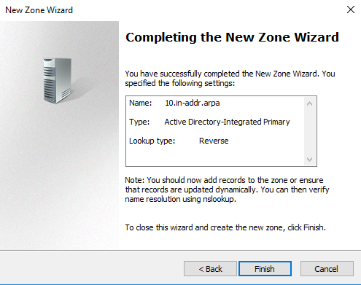
Figure: Reverse zone wizard — 10.in-addr.arpa, AD-integrated, Primary, Reverse.

2.3.1.2. Creating DNS record
Most DNS records are registered automatically by client computers when they obtain a DHCP lease. Static records (such as the corporate web server) are added manually:
- In DNS Manager, expand Forward Lookup Zones and click on xyz.local.
- Right-click on xyz.local and select New Host (A or AAAA).
- Type the host name (for example, web) and the IP address (10.0.0.20).
- Click Add Host, OK, and Done.
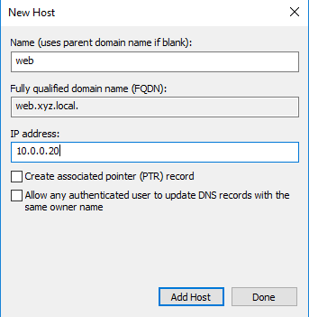
Figure: New Host dialog — web.xyz.local pointing to 10.0.0.20.
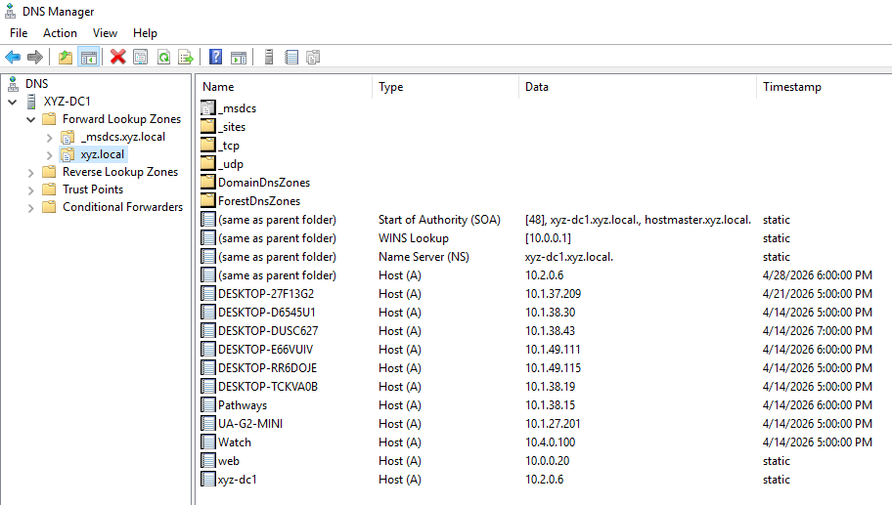
Figure: Forward zone xyz.local with all records, including the new web host and the WINS Lookup record.

2.3.2. WINS
Windows Internet Name Service (WINS) resolves NetBIOS names (the legacy 15-character single-label names) to IP addresses. Although DNS has replaced WINS in modern environments, the role is still requested by the project specification and is installed for compatibility with legacy applications.

2.3.2.1. Configuring DNS
The WINS role is installed from Server Manager and integrates automatically with the existing DNS zone:
- From the desktop, open Server Manager.
- Click Manage > Add Roles and Features.
- Click Next until the Features page; check WINS Server, accept any prompted required features, click Next.
- Click Install and wait for the installation to complete; click Close.
- Open Server Manager > Tools > WINS to verify that the WINS console connects to XYZ-DC1.

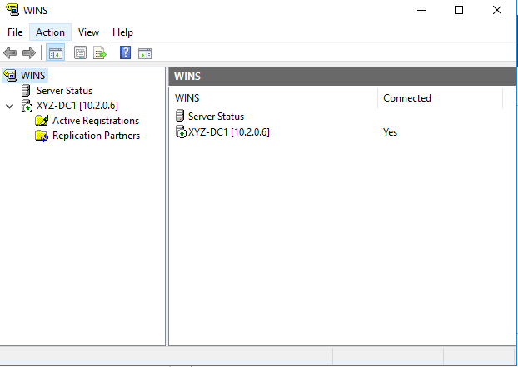
Figure: WINS console — XYZ-DC1 [10.2.0.6] connected.

Inside the DNS zone xyz.local, a WINS Lookup record is created automatically that lets DNS query WINS as a fallback when a name is not found in the zone. This integration is also visible in the Forward Lookup Zones screenshot above.
The DHCP server is also configured to update DNS records dynamically on behalf of older clients that can’t register themselves. The dynamic update settings are accessed from the IPv4 Properties of the DHCP server, on the DNS tab.

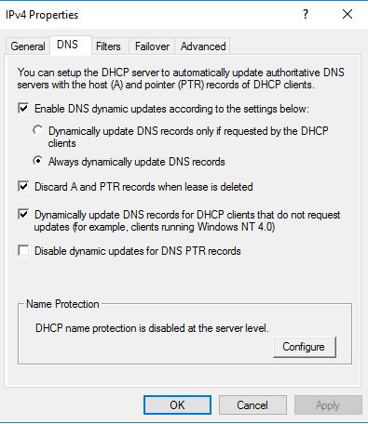
Figure: Dynamic DNS update settings on the DHCP server.

2.3.3. DHCP
Dynamic Host Configuration Protocol (DHCP) leases IP addresses, subnet masks, default gateways, and DNS server addresses to client computers automatically. The DHCP role was added through Server Manager and authorized in Active Directory before configuring the scope.

2.3.3.1. Configuring DHCP scope
A scope is the range of IP addresses that DHCP can lease. For XYZ Company, the scope covers the entire 10.0.0.0/8 network, and the first 50 addresses are excluded so they can be reserved for servers, printers, and network equipment.
- From the desktop, open Server Manager > Tools > DHCP.
- Expand XYZ-DC1.xyz.local > IPv4. Right-click IPv4 and choose New Scope.
- Click Next, type a scope name (for example, XYZ Corporate) — Next.
- Type 10.0.0.1 as Start IP and 10.255.255.254 as End IP, with subnet mask 255.0.0.0 — Next.
- On the Add Exclusions page, type Start 10.0.0.1 and End 10.0.0.50, click Add — Next.
- Continue with Lease Duration, Router (gateway), and DNS settings as appropriate; finish the wizard and activate the scope.
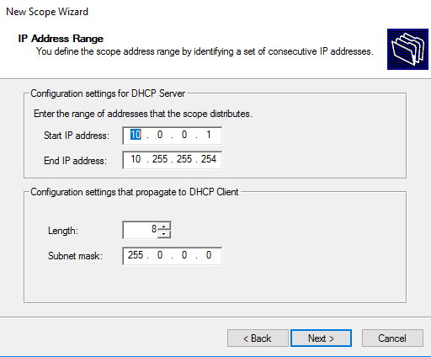
Figure: IP Address Range — 10.0.0.1 to 10.255.255.254 with /8 mask.

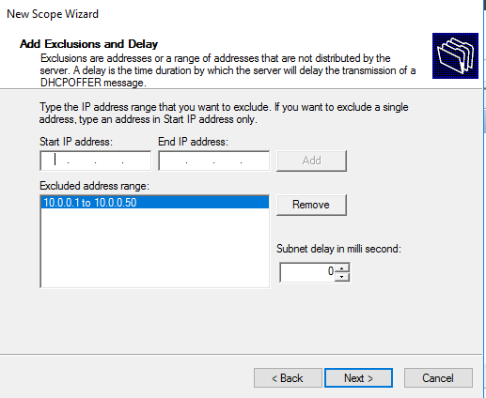
Figure: Exclusion 10.0.0.1 to 10.0.0.50 reserves the first 50 addresses for static use.

2.3.3.2. Configuring reservations
A reservation guarantees that a specific computer always receives the same IP address from DHCP, identified by its MAC address. Two reservations are required by the project: Finance-DB and IT-Fileserver. Reservations are created inside the scope, after the scope is activated.
- In DHCP Manager, expand the active scope and right-click on Reservations.
- Choose New Reservation.
- Type a reservation name (for example, Finance-DB), the IP address (10.0.0.10), and the MAC address (11-22-33-44-55-66) — Add.
- Repeat for IT-Fileserver with IP 10.0.0.11 and MAC 33-44-55-66-77-88. Click Close.

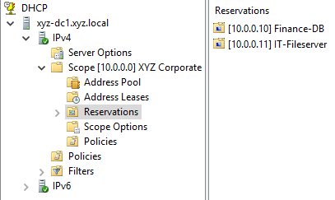
Figure: Reservations branch with Finance-DB (10.0.0.10) and IT-Fileserver (10.0.0.11).

2.4. Computers

2.4.1. Creating Computers
Computer accounts represent the workstations and servers that join the domain. They are normally created automatically when a machine joins the domain, but they can also be pre-created so that the IT department controls in advance the OU where each computer will live and the user account that is allowed to join it. The four computers used in the demonstration are pre-created in their corresponding OUs.
- From the desktop, open Server Manager > Tools > Active Directory Users and Computers.
- In the left pane, right-click on the OU that should contain the computer (for example, Marketing).
- Choose New > Computer.
- Type the computer name (for example, MKTG-PC1) and click OK.
- Repeat for each computer of the demonstration: Finance-DB, MKTG-PC1, MKTG-PC2, IT-Fileserver.
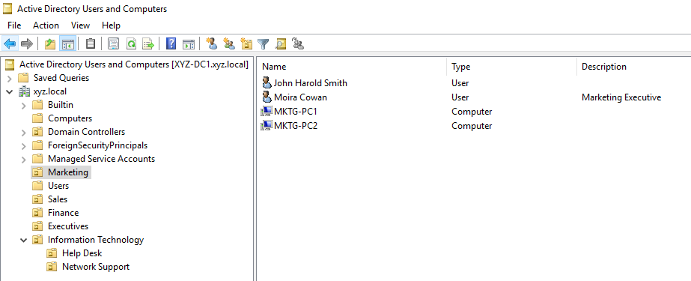
Figure: Marketing OU contains MKTG-PC1, MKTG-PC2, Moira Cowan, and John Harold Smith.
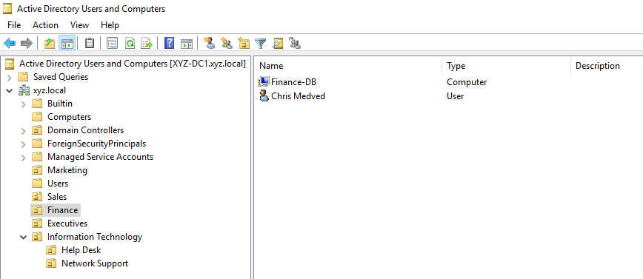
Figure: Finance OU contains Finance-DB and Chris Medved.
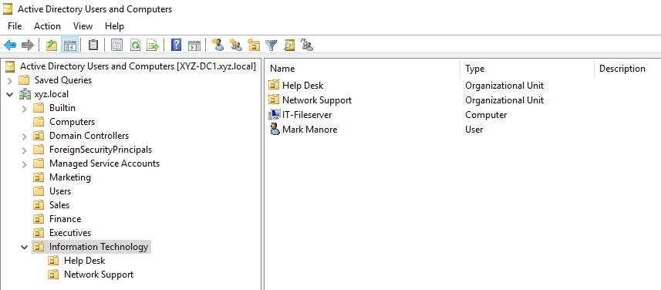
Figure: Information Technology OU with the sub-OUs Help Desk and Network Support, plus the IT-Fileserver computer and Mark Manore.
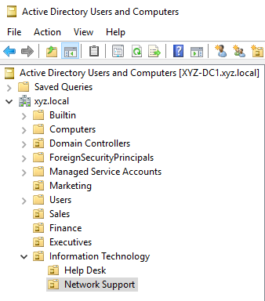
Figure: Complete OU hierarchy of the xyz.local domain.

2.5. Group Policy
A Group Policy Object (GPO) is created in Group Policy Management, edited in Group Policy Management Editor, and linked to a site, domain, or Organizational Unit. The single GPO created for this demonstration is named Marketing Policy and is linked exclusively to the Marketing OU.

2.5.1. Linking Policies
A GPO has two parts: the policy object itself (stored once in Group Policy Objects) and the link (the relationship that ties the GPO to a container). Linking is what causes the policy to actually apply to the users and computers inside the chosen container.
- From the desktop, open Server Manager > Tools > Group Policy Management.
- Expand Forest: xyz.local > Domains > xyz.local.
- Right-click on Group Policy Objects and choose New. Type Marketing Policy as the name and click OK.
- Right-click on the Marketing OU and choose Link an Existing GPO.
- Select Marketing Policy and click OK.
- Confirm the link by clicking on the Marketing OU and checking the Linked Group Policy Objects tab — Link Enabled should be Yes.
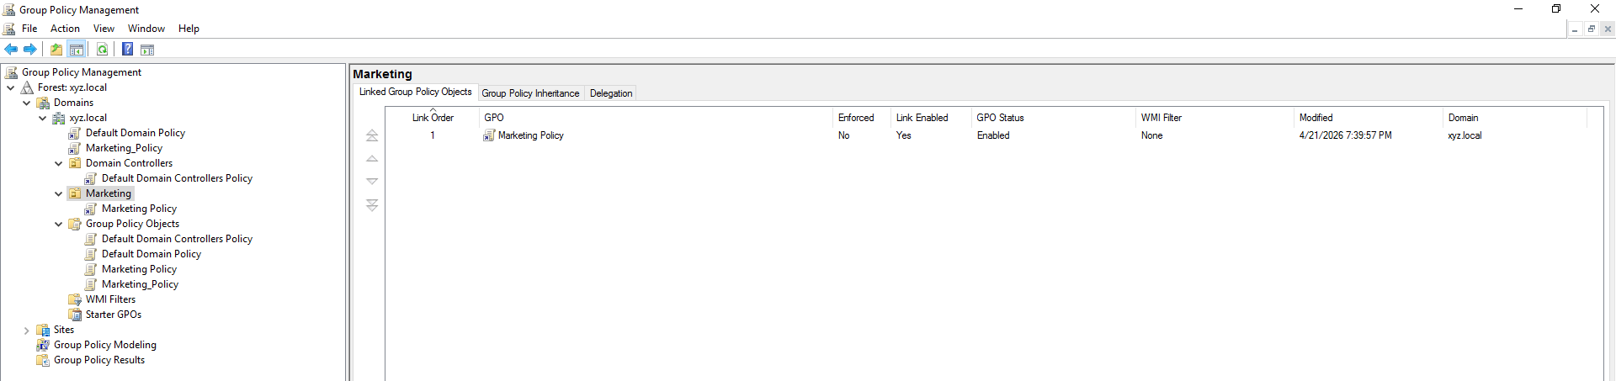
Figure: Marketing OU with Marketing Policy linked, Link Enabled = Yes, GPO Status = Enabled.
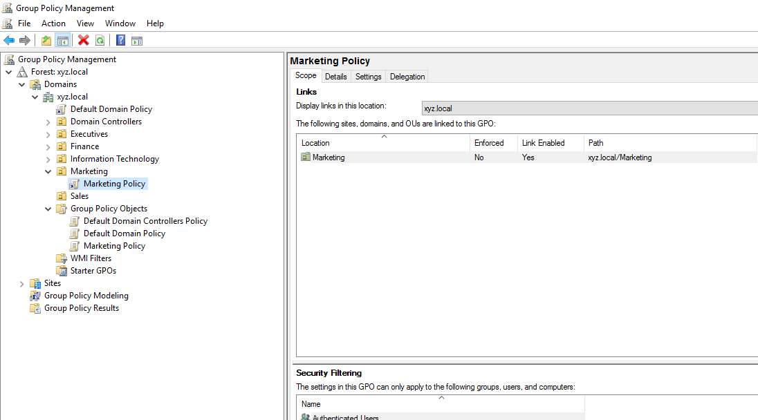
Figure: Marketing Policy — Scope tab confirms the link to xyz.local/Marketing.

2.5.2. Creating General Policies
General Policies in this project are the user-environment restrictions that standardize the desktop of every Marketing user. They are configured under User Configuration > Policies > Administrative Templates inside the GPO editor. To open the editor: in Group Policy Management, right-click Marketing Policy and choose Edit.
The wallpaper is enforced through two related settings. First, Desktop Wallpaper specifies the image file path and the display style. Second, prevent changing desktop background disables the personalization options on the client. The image file (XYZ_Background.jpg) must exist in the path specified, accessible by the user account.
- In the editor, navigate to User Configuration > Policies > Administrative Templates > Desktop > Desktop.
- Double-click Desktop Wallpaper, choose Enabled, type C:\Windows\Web\Wallpaper\XYZ_Background.jpg in Wallpaper Name, choose Fill in Wallpaper Style, click Apply and OK.
- Double-click Prevent changing desktop background, choose Enabled, click Apply and OK.
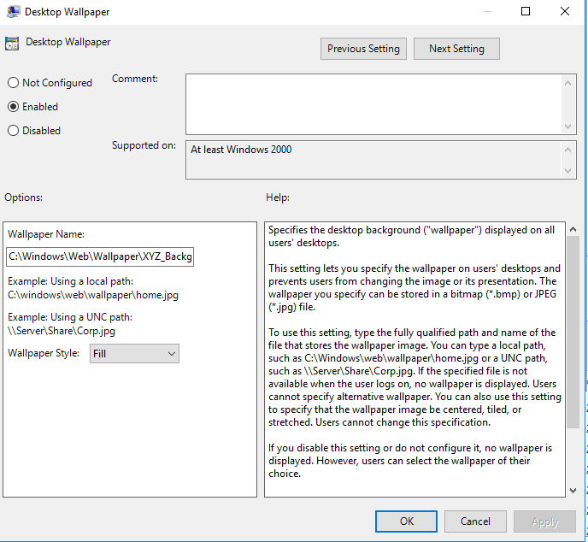
Figure: Desktop Wallpaper — Enabled, full path, Fill style.
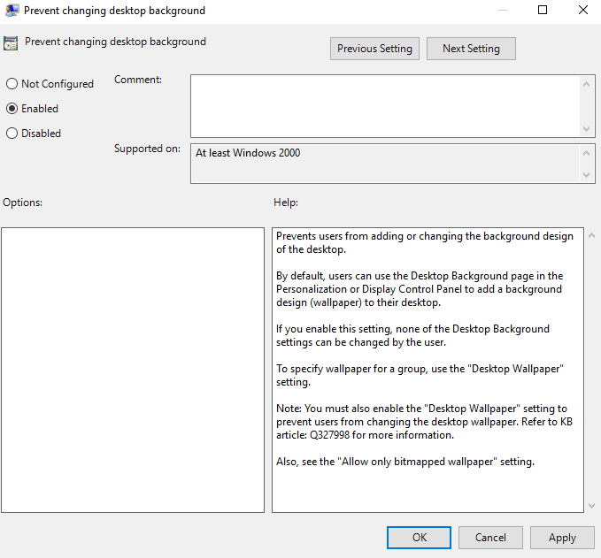
Figure: Prevent changing desktop background — Enabled.
The same Administrative Templates branch contains the icons and menu restrictions:
- User Configuration > Policies > Administrative Templates > Desktop > Remove Recycle Bin icon from desktop — Enabled.
- User Configuration > Policies > Administrative Templates > Start Menu and Taskbar > Remove Documents icon from Start Menu — Enabled.
- Same branch > Remove Run menu from Start Menu — Enabled.
- Same branch > Remove username from Start Menu — Enabled.
- User Configuration > Policies > Administrative Templates > Control Panel > Prohibit access to Control Panel and PC settings — Enabled.

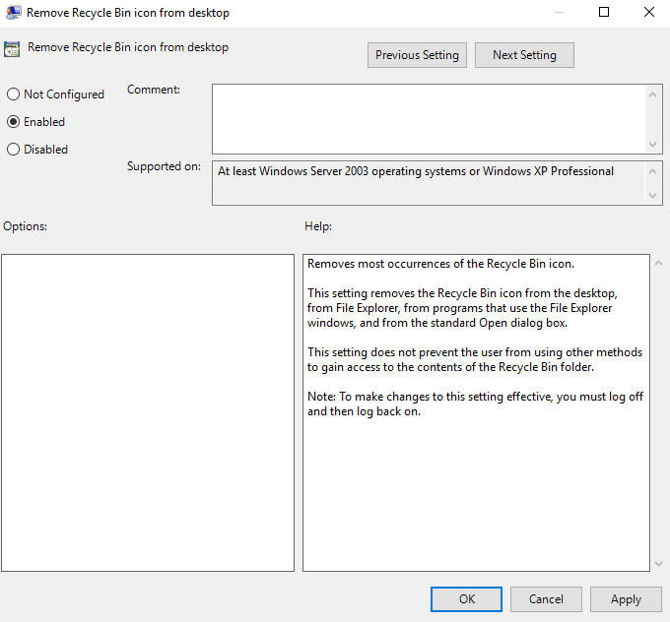
Figure: Remove Recycle Bin icon from desktop — Enabled.
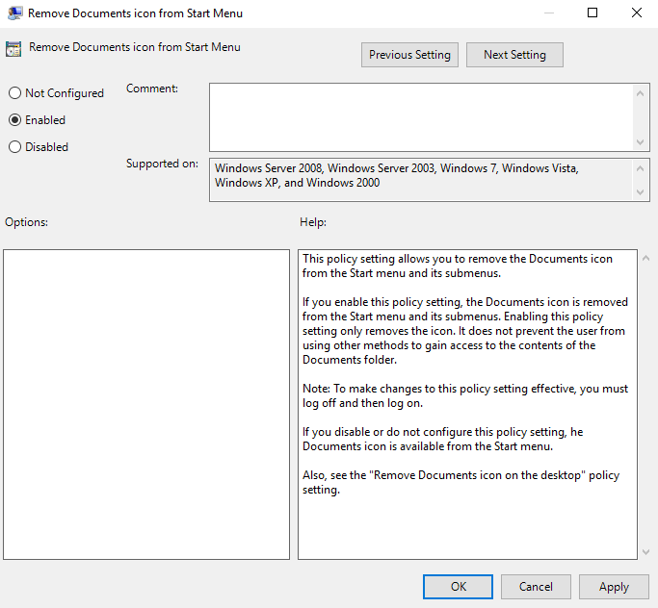
Figure: Remove Documents icon from Start Menu — Enabled.

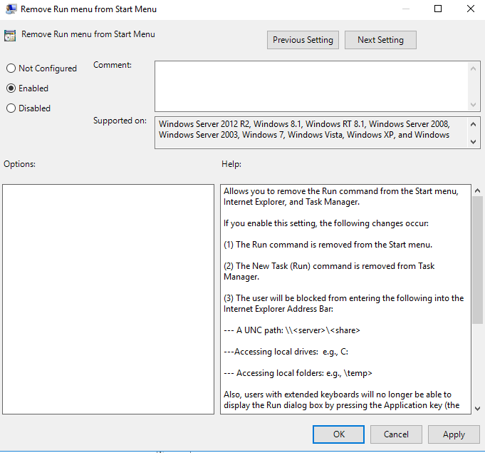
Figure: Remove Run menu from Start Menu — Enabled.
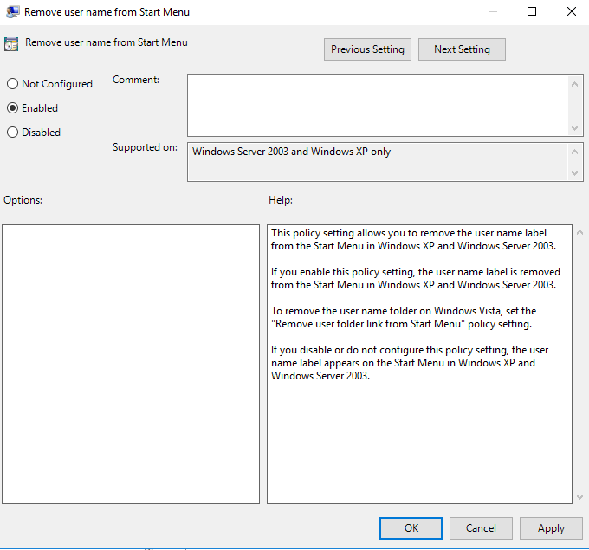
Figure: Remove user name from Start Menu — Enabled.
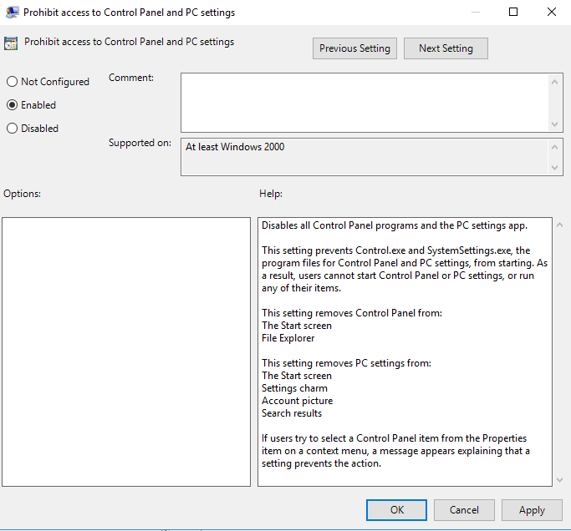
Figure: Prohibit access to Control Panel and PC settings — Enabled.

2.5.3. Creating Security Policies
Security Policies in this project enforce password complexity and the account-lockout behavior. They are configured under Computer Configuration > Policies > Windows Settings > Security Settings inside the GPO editor.
Password Policy:
- Computer Configuration > Policies > Windows Settings > Security Settings > Account Policies > Password Policy.
- Double-click Enforce password history, check Define this policy setting, type 12, OK.
- Double-click Minimum password length, check Define this policy setting, type 5, OK.
- Double-click Password must meet complexity requirements, check Define this policy setting, choose Enabled, OK.

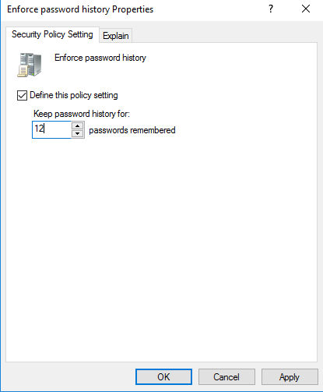
Figure: Enforce password history — 12 passwords remembered.
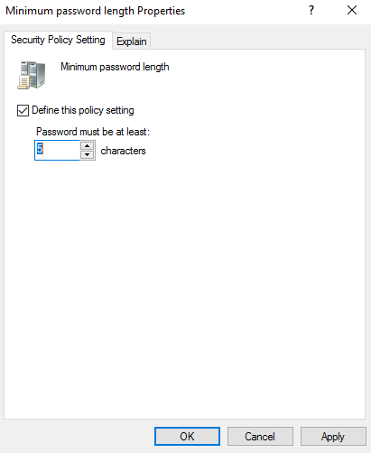
Figure: Minimum password length — 5 characters.
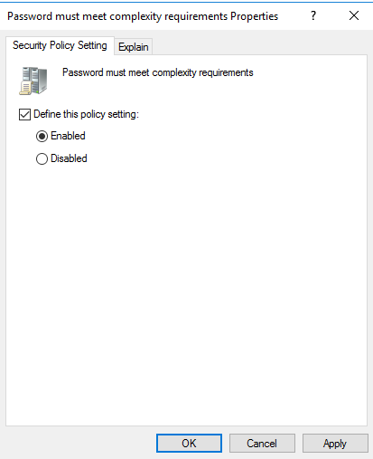
Figure: Password must meet complexity requirements — Enabled.
Account Lockout Policy:
- Same path > Account Lockout Policy.
- Double-click Account lockout threshold — 3 invalid logon attempts.
- Double-click Account lockout duration — 15 minutes.
- Double-click Reset account lockout counter after — 5 minutes.

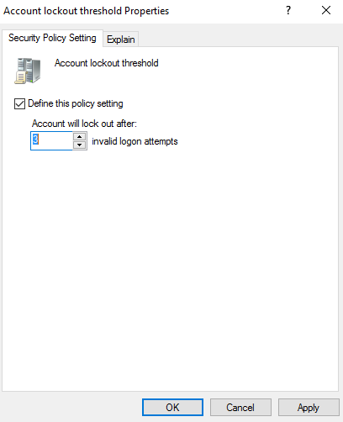
Figure: Account lockout threshold — 3 invalid logon attempts.
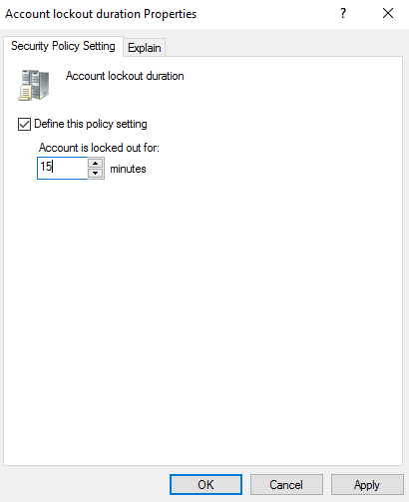
Figure: Account lockout duration — 15 minutes.
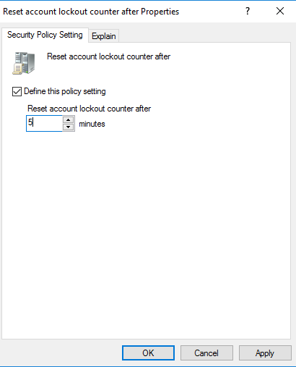
Figure: Reset account lockout counter after — 5 minutes.
Logon Banner. The XYZ Security Policy message is displayed at every interactive logon. It is configured as a Security Option:
- Computer Configuration > Policies > Windows Settings > Security Settings > Local Policies > Security Options.
- Double-click Interactive logon: Message text for users attempting to log on, check Define this policy setting, type the security policy text, click OK.
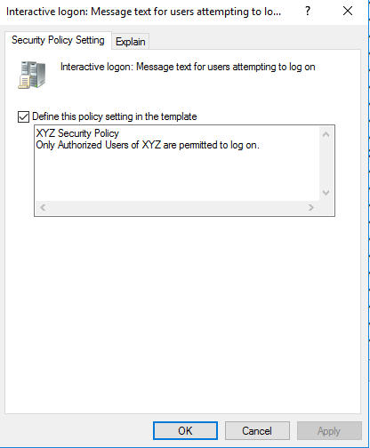
Figure: Interactive logon message — XYZ Security Policy.

2.5.4. Managing File System Permissions
The Reports folder lives on C:\Reports of the Domain Controller and is shared across the network so that Marketing users can access it. Permissions are granted at two levels: Share-level (controls access through the network) and NTFS (controls access through the file system, more granular).
- From the desktop, open File Explorer and create the folder C:\Reports.
- Right-click on Reports > Properties > Sharing tab > Advanced Sharing — check Share this folder, set the share name to Reports, click Permissions, add Marketing Users with Read permission, OK, OK.
- On the Security tab, click Edit > Add, type Marketing Users, click Check Names, OK; check Read & execute, List folder contents, Read; OK and OK.
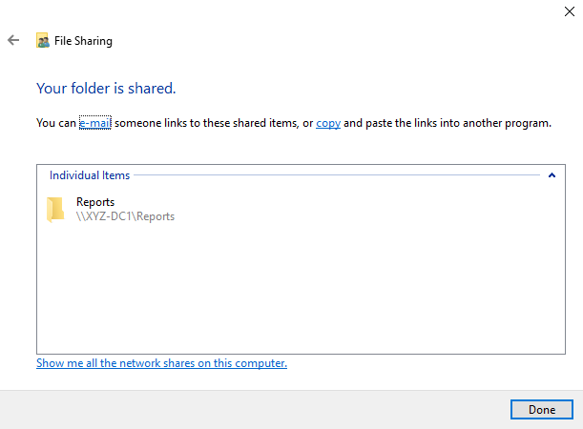
Figure: File Sharing dialog — Reports folder shared as \\XYZ-DC1\Reports.
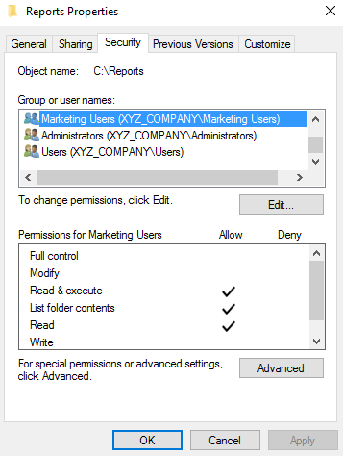
Figure: Security tab on C:\Reports — Marketing Users with Read & execute, List, Read.

2.5.5. Software Deployment
GPOs can publish or assign software to users so that the application is installed automatically without user interaction. In this project, 7-Zip is assigned to every Marketing user; the MSI installer is hosted on a network share so that any computer in the domain can pull it during logon.
- From the desktop, create the folder C:\Software, copy the 7-Zip MSI inside it, and share the folder as Software (Read for Authenticated Users on the share, Read on NTFS).
- In Group Policy Management, right-click on Marketing Policy > Edit.
- Navigate to User Configuration > Policies > Software Settings > Software installation.
- Right-click on Software installation and choose New > Package.
- Browse to the share \\XYZ-DC1\Software\7z2409-x64.msi and click Open.
- Choose Assigned, click OK.
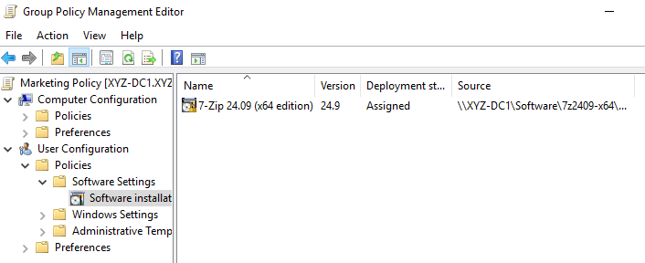
Figure: Software installation — 7-Zip 24.09 (x64 edition) Assigned, single deployment, sourced from \\XYZ-DC1\Software\7z2409-x64.msi.
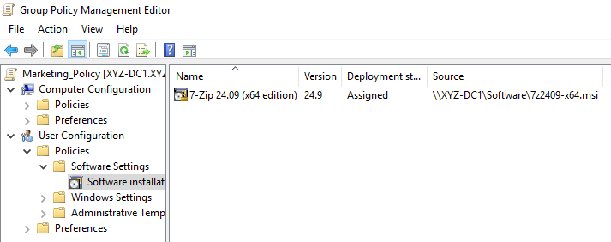
Figure: Group Policy Management Editor with the Software installation node selected.

2.6. Validating the Implementation
Two procedures verify that the configuration works as expected without requiring an interactive logon as a domain user on the Domain Controller. The first is the Group Policy Modeling Wizard, which simulates the application of GPOs for a given user/computer combination. The second is the Settings tab of the GPO itself, which generates a complete report of every value configured.
To run the Modeling Wizard:
- In Group Policy Management, right-click Group Policy Modeling > Group Policy Modeling Wizard.
- Click Next on the Welcome page, accept the default Domain Controller, click Next.
- On User and Computer Selection, click Browse for the user (for example, MCowan) and the computer (MKTG-PC1), click Next.
- Accept defaults through the rest of the wizard, click Next on the Summary, then Finish.
- Review the resulting report, especially the Applied GPOs and Denied GPOs lists.

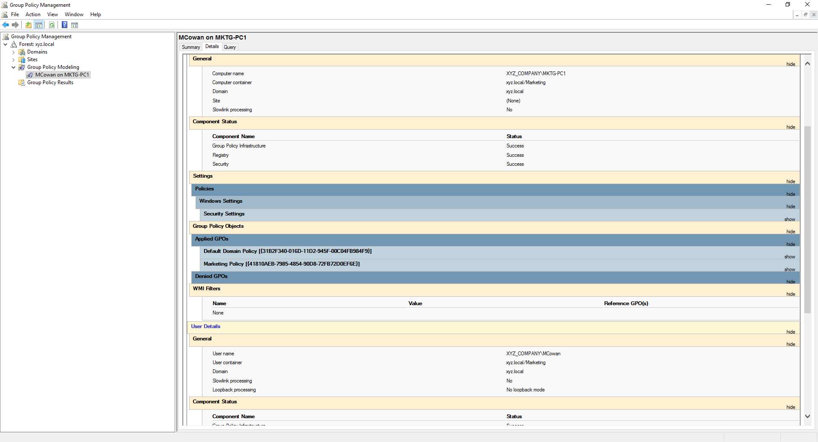
Figure: Modeling result for MCowan on MKTG-PC1 — Marketing Policy listed in Applied GPOs and all components show Success.
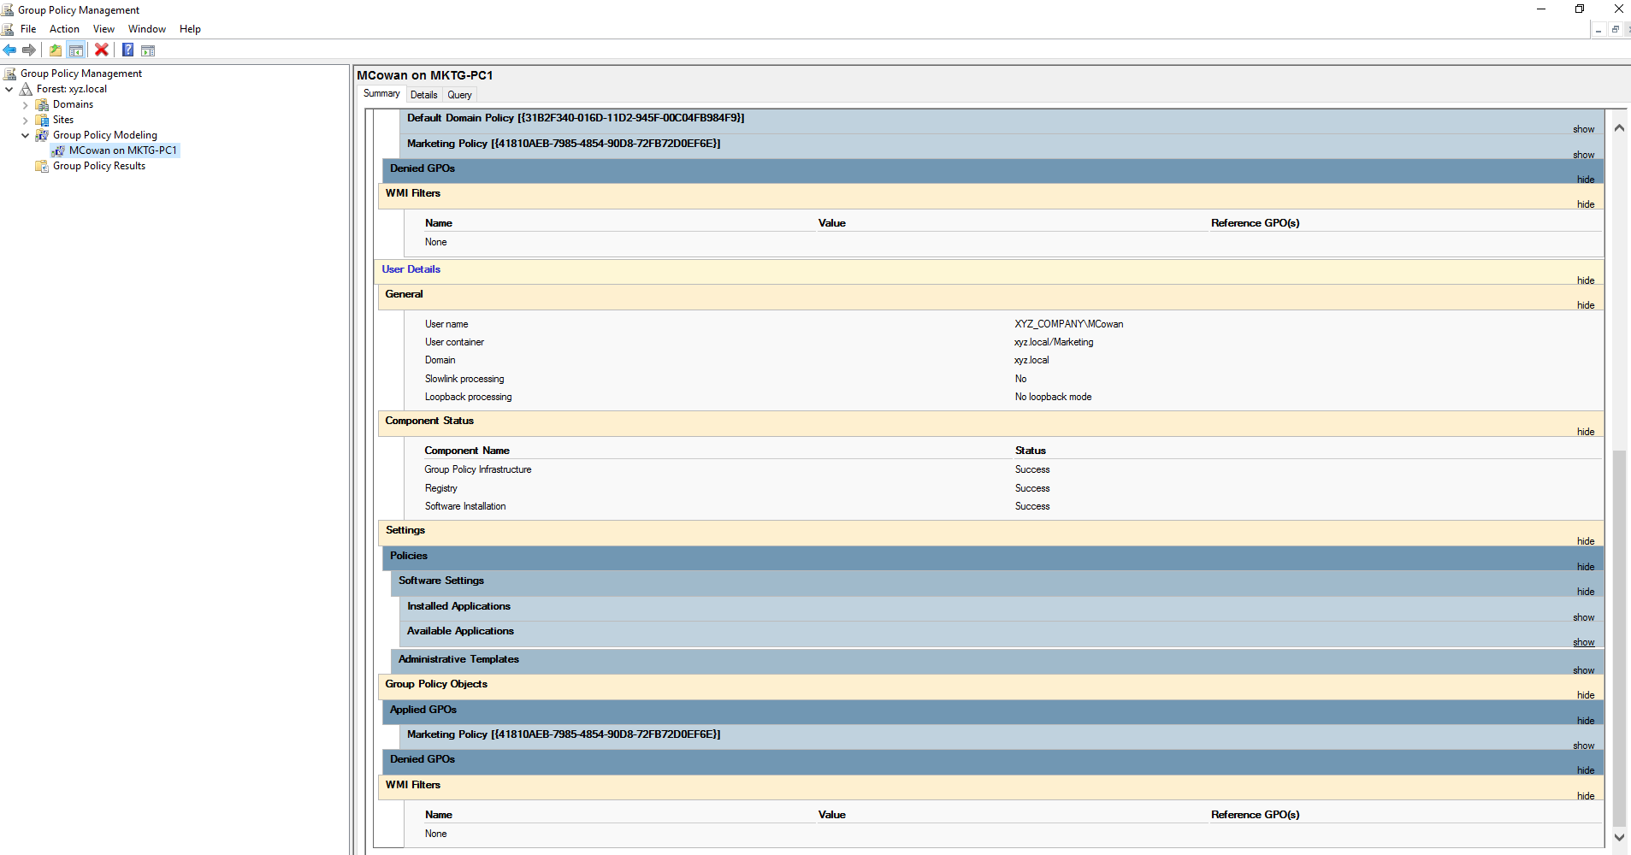
Figure: Modeling — Settings tab confirms Software Installation, Group Policy Objects, and Applied GPOs.

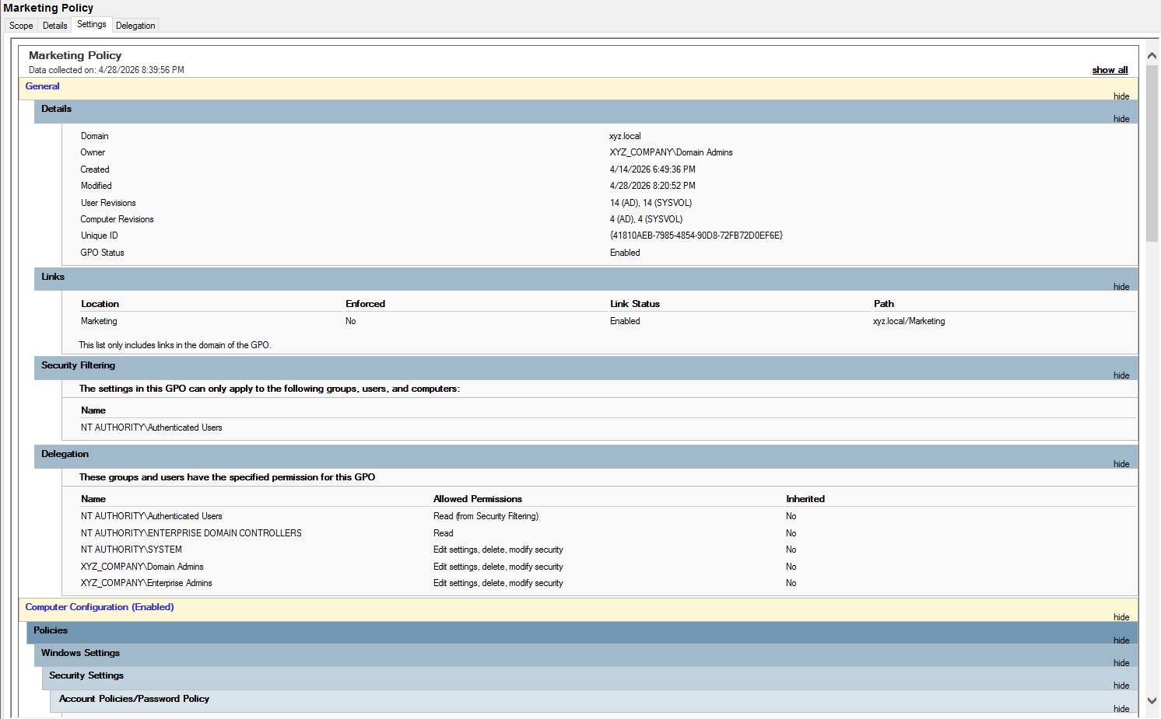
Figure: Marketing Policy Settings report — General details, Links, Security Filtering, and Delegation.
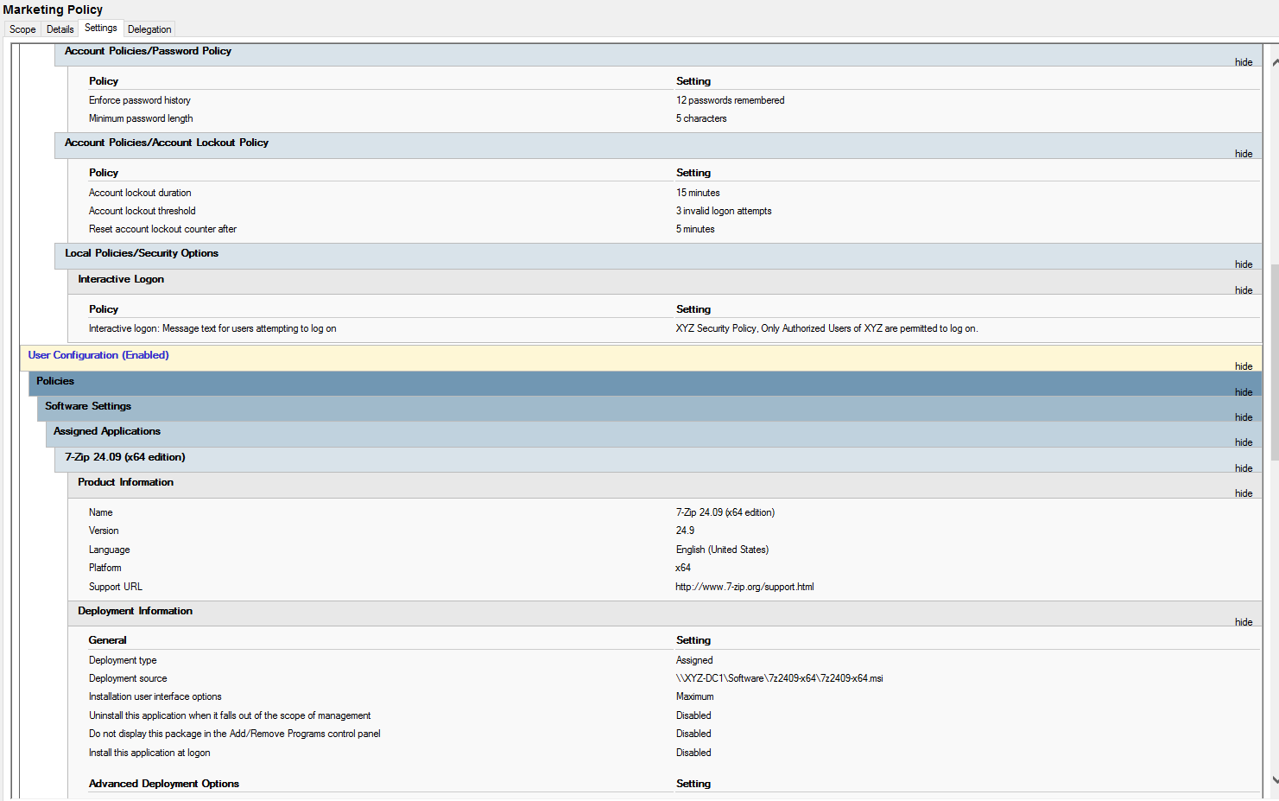
Figure: Marketing Policy Settings report — Account Policies, Local Policies, and Software Settings.

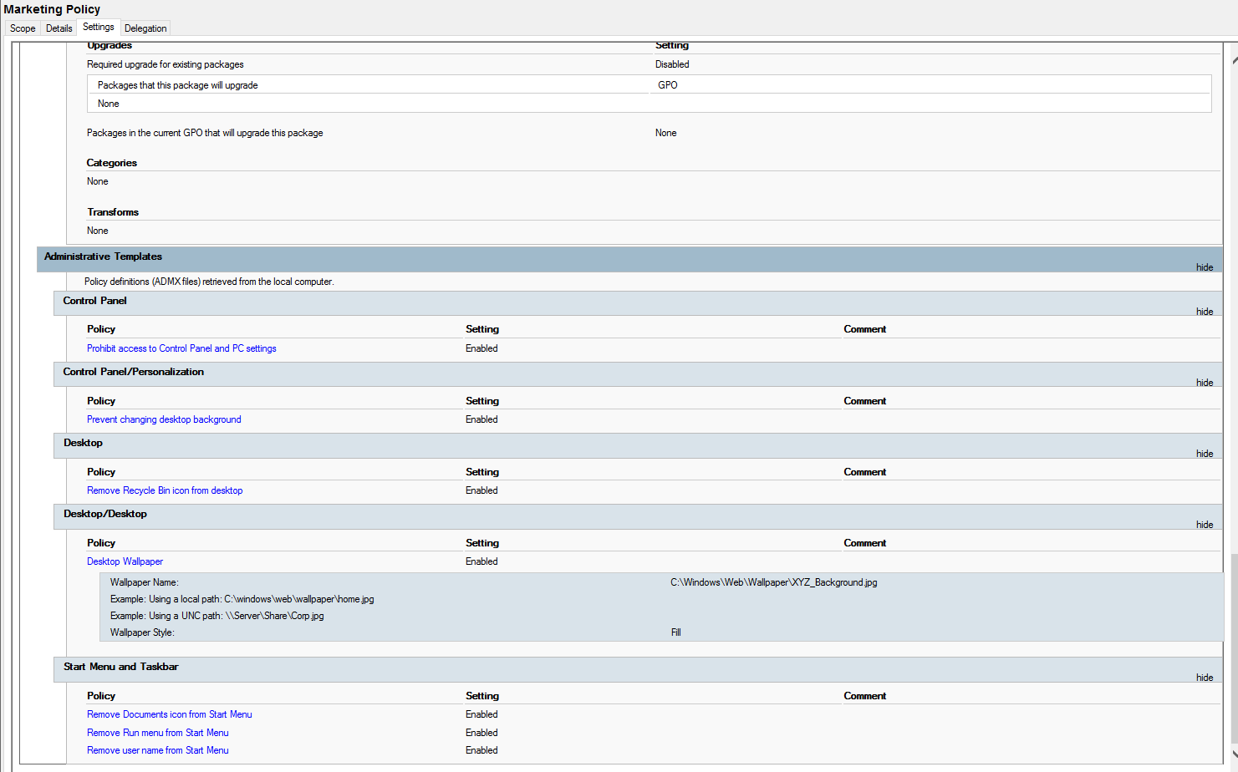
Figure: Marketing Policy Settings report — Administrative Templates including Desktop Wallpaper.
Confirmation of the GPO refresh is captured at the Administrator command prompt:
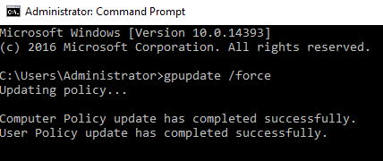
Figure: gpupdate /force — Computer Policy and User Policy updated successfully.

3. References
DiNicolo, D. (2003). Hands-on Microsoft Windows Server 2003
administration. Cengage Learning.

Microsoft. (n.d.-a). Active Directory Domain Services overview.
Microsoft Learn. Retrieved May 2026, from
https://learn.microsoft.com/en-us/windows-server/identity/ad-ds/
get-started/virtual-dc/active-directory-domain-services-overview

Microsoft. (n.d.-b). Active Directory security groups.
Microsoft Learn. Retrieved May 2026, from
https://learn.microsoft.com/en-us/windows-server/identity/ad-ds/
manage/understand-security-groups

Microsoft. (n.d.-c). Group Policy overview for Windows Server.
Microsoft Learn. Retrieved May 2026, from
https://learn.microsoft.com/en-us/windows-server/identity/ad-ds/
manage/group-policy/group-policy-overview

Microsoft. (n.d.-d). DHCP Server role documentation.
Microsoft Learn. Retrieved May 2026, from
https://learn.microsoft.com/en-us/windows-server/networking/
technologies/dhcp/dhcp-top

Microsoft. (n.d.-e). DNS Server role documentation.
Microsoft Learn. Retrieved May 2026, from
https://learn.microsoft.com/en-us/windows-server/networking/
dns/dns-top

Tomsho, G. (2017). Hands-on Microsoft Windows Server 2016.
Cengage Learning.

